“Obama’s Way”
By Michael Lewis
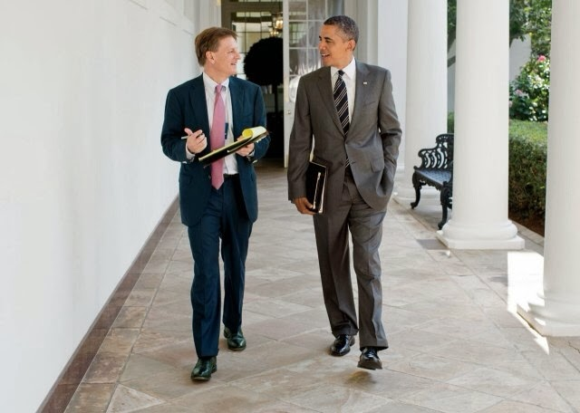
AS WE LISTEN:
As we listen to the interview with Terry Gross, please follow along intently and take copious notes. Your notes should focus on the role of the U.S. President, the challenges he faces and the decisions he makes.
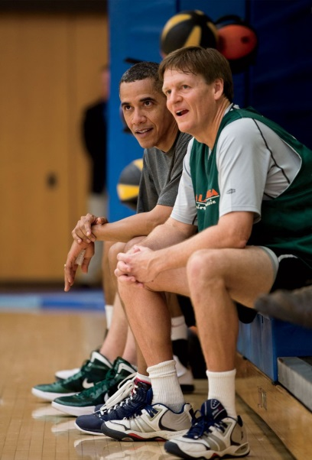
AFTER THE INTERVIEW:
We will take the next 20-25 minutes to write a well-crafted response to what we just heard. There is no definitive format or prompt that you must address. But here are some ideas to help guide your thinking:

- In a well-crafted response, please describe Michael Lewis’s interactions with President Obama. What did Lewis learn about the president? More importantly, what did you learn about the role of the U.S. president? Did anything surprise you?

- Hypothetically speaking, if you were going to become the next president of the United States in the next 45 minutes, what advice did you take away from this interview? And how would that affect your role as the 45th president of the United States of America? Do you agree or disagree with Obama’s suggestions? Explain

