The Rise of Christianity in the Roman Empire
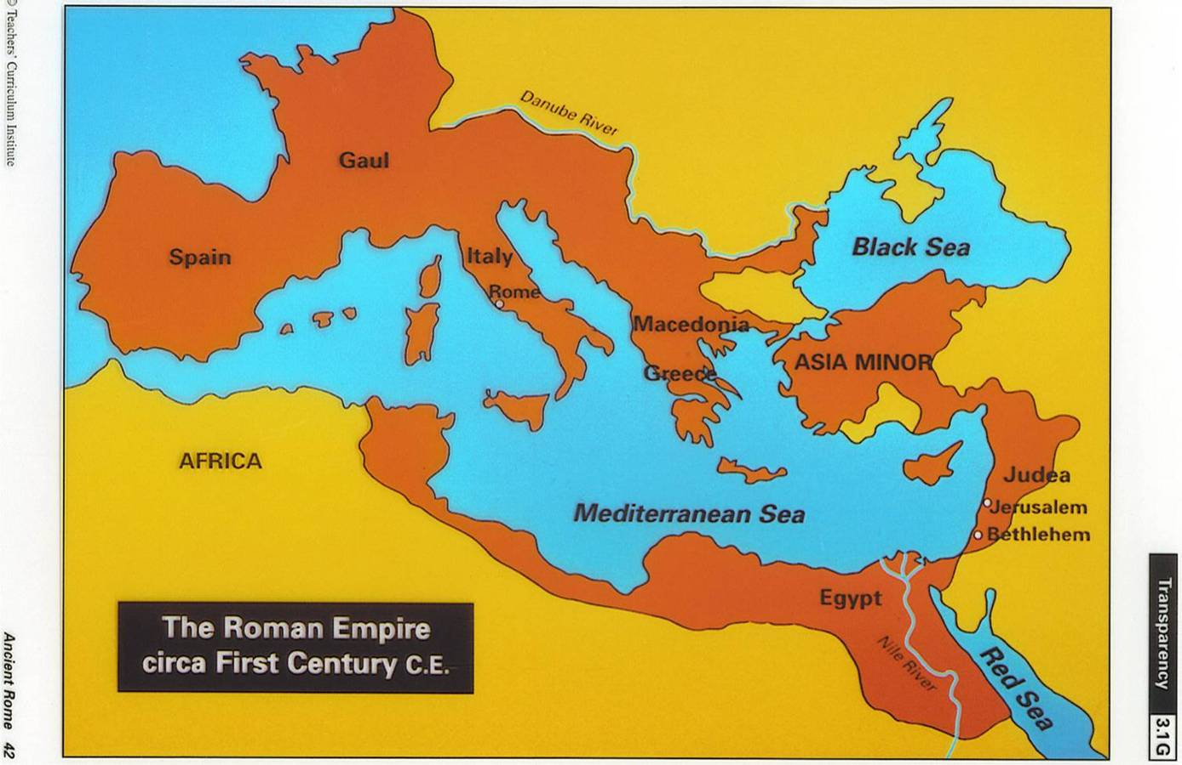

Christianity, the religion based on the teachings of Jesus Christ, had its beginnings in Judea - a Jewish - ruled kingdom that became a province of the Roman Empire in 63 B.C.E. To govern the small, distant region, Roman leaders put pro-Roman Jewish rulers in charge of states in which large numbers of Jews lived. However, after numerous groups of Jews revolted against Roman control, Rome appointed a pro-Roman Jewish convert named Herod to be King of Judea in 37 B.C.E. While Herod's leadership solidified Roman rule in the region, his harsh ways increased Jewish resistance against the empire.
When Herod died in 4 B.C.E., the kingdom of Judea was divided among his three sons. The sons wee unable to control anti-Roman Jewish dissent, so Rome stationed soldiers in Judea and replaced Herod's sons with a Roman ruler, called the prefect. The prefect in Judea usually concerned himself with the regions' politics and economics - making sure tribute was paid to Rome - but left local government in the hands of Jewish leaders. For example, Jerusalem, the Jewish holy city, was ruled by the Jewish high priest. One prefect who became unusually involved in Jerusalem's religious affairs was Pontius Pilate (pronounced PON-chuss PY-lit). Pilate, who was the prefect of Judea from 26 to 37 C.E., oversaw the trial and execution of Jesus.
While historical records provide plenty of information about Roman rule and life throughout the empire, developing an accurate historical picture of Jesus of Nazareth has been difficult, because there are few historical records about his life. However, from the works of non-Christian writers who referred to Jesus, and the many Christian works written about him, it is generally accepted that Jesus did live. The greatest source of information about Jesus' life is in the New Testament of the Christian Bible, particularly the Gospels. The Gospels, by Matthew, Mark, Luke, and John, were compiled from oral and written sources about Jesus' life between 30 and 70 years after his death. The Gospel writers were all followers of Jesus, and thus their works are recognized to be sources that were intended to be for the believing community. They are not considered to be historical biographical documents, but rather accounts of Jesus' life and teachings.
Step 1: Match New Testament Passages to Pictures - Cut out each of the Bible Passages Handout and match them with the pictures in the Key Event in the Development of Christianity Handout.
Step 2: Note-Taking: Key Points and Connections to the Text (Passages) - Look at the pictures below that are also in the Key Events in the Development of Christianity Handout and read the corresponding text that follows (below). Take notes based on the information and underline key words or phrases that exist in the Bible Passages Handout that you matched to the pictures.
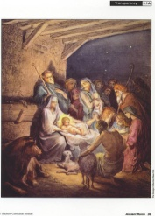EVENT A: The Birth of Jesus - Engraving of the Nativity scene in Bethlehem. Joseph stands behind Mary, who props up the infant Jesus while shepherds look on in amazement.
According to Luke, Joseph went to Bethlehem to register in a census ordered by the Roman emperor, Caesar Augustus. Nazareth, which is said to be the city of Jesus' childhood, is located in Galilee. Galilee is the northern region of present-day Israel. In this passage, Judea refers to the region wherein Bethlehem and Jerusalem are located, south of Galilee.
Information about Event A:
The precise date of Jesus' birth is unknown. For centuries, it was assumed that Jesus was born at the beginning of the Common Era - in fact, the western calendar is based on this assumption. However, by evaluating the different dates provided in the gospel accounts of his birth, along with Roman historical records, scholars now point to 6 B.C.E., during Herod's reign, as Jesus' approximate birth date. Though little can be verified about the circumstances of Jesus' birth, the birth stories in the Gospels of Matthew and Luke are the basis of Christian belief about this event.
According to the Gospel of Luke, before Jesus was born, the archangel Gabriel appeared to Jesus' mother, Mary, who lived in Nazareth, a small town among the hills, in Galilee. The angel told Mary that she would have a child and that she should name him Jesus. The Gospel says that soon thereafter the Roman Emperor, Augustus Caesar, ordered a census to be taken of all the people of the empire. Because the census required that each man be registered in the town of his birth, Mary's husband, a carpenter named Joseph, traveled to Bethlehem, where he had been born. The pregnant Mary accompanied him on the 90-mile journey from Nazareth to Bethlehem. The Gospel of Luke says that when Mary and Joseph arrived in Bethlehem they were forced to seek shelter in a stable because there was nor room in the inn. Mary gave birth to her baby there, a boy she named Jesus.
Little is known about Jesus' childhood. It is probable that he grew up in Nazareth. it is also assumed that, as was the custom of the time and place, Jesus began to work alongside Joseph at an early age to learn his father's trade, carpentry. Like many Jewish boys of his time, Jesus probably studied the Jewish laws and customs, learned to read and write, and memorized versus of the Torah, the Jewish religious text. The only event of Jesus' childhood that is recorded in the Gospels is his meeting with the rabbis of the Temple of Jerusalem when he was 12 years old. The Gospel of Luke states that the rabbis were amazed by how well Jesus answered questions during a discussion and interpretation of Jewish law.
The Gospels relate that Jesus' ministry began when he was about 30 years old, after he was baptized by John the Baptist. John was a Jewish preacher who lived on the banks of the Jordan River. He preached about the importance of returning from evil ways to God, or repentance, and leading a just life. For example, in the Gospel of Luke, John teaches, "He who has two coats, let him share with him who has none: and he who has food, let him do likewise." John also emphasized the importance of baptism in preparation for the coming of the Messiah, the savior-king that Jews believed God would send. Jesus was one of the many who came to be baptized, and John identified him as the Messiah. All four Gospels present Jesus' baptism by John as an event that transformed Jesus' life. The Gospels relate that immediately after his baptism, Jesus went into the wilderness or barren hills above the Jordan valley and stayed there for 40 days. Some theologians believe that it was during this time that Jesus began to accept that he was the Messiah about whom John spoke, although he never proclaimed himself to be the Messiah. Jesus returned to Nazareth, where he began preaching a message similar to John's.
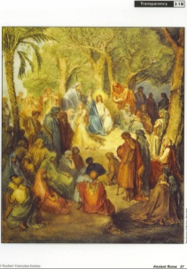EVENT B: Jesus' Teachings - Engraving of Jesus seated on the side of a mountain in Galilee, preaching to people of all ages.
This is a picture from the Sermon on the Mount, one of the longest and most important speeches made by Jesus. Included in this sermon are the beatitudes, or statements about how people should conduct themselves, and what rewards they will receive for righteous behavior. It also includes the words that became an important Christian prayer that begins with: "Our Father." Part of the sermon was also the basis for the "Golden Rule," which states: "Whoever ye would that men should do to you, do ye even so to them."
Information about Event B:
Jesus' early ministry consisted of teaching Jews in the villages and small towns of Galilee. Most typically, the Gospels say, he went from village to village, preaching in synagogues on the Sabbath. As Jesus developed a reputation, the crowds who listened to him grew larger, and he began to teach in open areas - in the street, in the countryside, and by the sea of Galilee. Early in his ministry, Jesus called a small number of men to be his followers, or disciples. These disciples - all but one of whom wee from the laboring class - traveled with him as he spoke before increasing numbers of Jews, Samaritans, and others.
Jesus based his teachings on traditional Jewish beliefs, emphasizing the qualities of love and mercy. According to the Gospels, Jesus taught that of all the Jewish laws, two commandments were the greatest. The first was, "You shall love the Lord your God with all your heart, and with all your soul, and with all your mind, and with all your strength." The second was, "You shall love your neighbor as yourself" (Mark 12:28 - 34). Jesus preached that living a new life filled with loving kindness, purity of heart, and devotion to God would help people prepare for the coming Kingdom of God. This kingdom, called the Kingdom of Heaven in the Gospel of Matthew, referred to an age when people would live according to God's will and gain eternal life.
One of the ways Jesus taught was to speak in parables, simple stories that contained important messages. Often, parables illustrated Jesus' emphasis on the love that God had for humanity. They also emphasized the loving care that God expected people to have for others, regardless of their different religions. For example, in the parable of the God Samaritan, recorded in the Gospel of Luke, Jesus tells the story of a Jewish traveler who is robbed, beaten, and left to die on the side of the highway. After two men from the temple hierarchy avoid him, a Samaritan (a member of a religious sect considered heretical at that time) stops and helps him, eventually taking him to an inn and paying for his treatment. Jesus then asks his listeners which of the three travelers proved worthy of God, and confirms that the Samaritan's actions proved worthy of God and the respect of others.
According to the Gospels, Jesus not only preached, but also performed miracles. Through speech and touch, Jesus cured diseases, restored people's sight, and in the Gospel of John, even raised a man from the dead. The Gospels also attribute to Jesus other types of miracles, such as calming storms, changing water to wine, and walking on water.
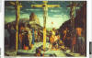 Event C: The Crucifixion and Resurrection - An oil painting of Jesus and two criminals crucified at Calvary outside Jerusalem. At right, Roman soldiers cast lots for Jesus' garment, while his mother Mary and other supporters huddle at left. The inscription above the cross is an acronym for "Jesus of Nazareth, the King of the Jews," the Latin phrase used by Pilate for identify Jesus.
According to John, once Jesus had been condemned to die, he was forced to carry the cross upon which he would be crucified. He carried the cross to Golgotha - known in English as "Calvary" - a small hill outside the city gates of Jerusalem where the Romans erected crosses to crucify criminals. The identity of the two men crucified beside Jesus is not known, but Christian tradition holds that they wee common criminals. The inscription atop Jesus' cross refers to the reason Jesus had been condemned; as John relates, some Jewish leaders claimed he had called himself the King of the Jews, a title they found blasphemous.
Information about Event C:
After a year or two of traveling and preaching, Jesus went to Jerusalem in 33 C.E. to celebrate the Jewish festival of Passover. During the time of Jesus' life, hundreds of thousands of Jews came to Jerusalem for Passover. Some Jews, who were unhappy with Roman control over Judea, would stage demonstrations against Rome or the pro-Roman Jewish leaders during the festival. As a result, the Roman prefect of Judea and a few thousand Roman soldiers stationed in the province came to Jerusalem during Passover to maintain peace and order.
The Synoptic, or similar, Gospels by Matthew, Mark, and Luke recount that Jesus entered the city triumphantly, and began teaching in the temple to great crowds. According to the Gospels, Jewish religious leaders called Pharisees resented and feared Jesus' popularity as a teacher. They thought his teachings undermined their authority. Jewish leaders from another sect, called Sadducees, were also upset because Jesus had driven bankers and vendors out of the temple on religious principles. Thus, the Gospels recount, these same groups conspired to seize Jesus during the Passover celebrations and try him for heresy.
The Gospels relate that soon thereafter, Jesus was betrayed by Judas Iscariot (pronounced JOO-duss iss-KAIR-ee-yut), one of his disciples, who brought the Jewish leaders to the Garden of Gethsemane (pronounced geth-SEH-muh-nee), where Jesus was praying. The high priest interrogated him. The Jewish authorities found Jesus guilty of blasphemy because they claimed he called himself the Son of God. Thus, they took Jesus to Pontius Pilate, the Roman prefect, for sentencing. Only the prefect could sentence someone to death.
According to the Gospels, Pilate found no fault with Jesus, but Roman officials and certain Jewish leaders urged Pilate to condemn him. Some historians believe that the officials wanted to have Jesus convicted to prevent trouble, especially during festivals. The Gospels relate that Pilate condemned Jesus to death by crucifixion. The Romans usually used crucifixion - a painful and lengthy method of execution - to kill criminals. Jesus was taken outside the city was, nailed to a cross, and left to die. After Jesus died, he was removed and buried in a tomb hewn out of rock in Jerusalem.
The Gospels recount that on the third day after Jesus' death and burial, he rose from the dead, an event Christians call the Resurrection. He then appeared to his disciples - as a living but transformed person - and encouraged them to teach his followers and to spread the message he had preached. The Resurrection convinced Jesus' disciples that he was the Son of God and inspired them to spread the Gospel, or Good News, of his teachings. The Resurrection became the defining event of Christianity.
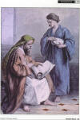 Event D: Missionary Work of Paul - An engraving of Paul writing letters to other Christians while imprisoned. The man at right waits to take the finished letters away.
In the Acts of Apostles, a book of the Bible that describes the Christian movement in the early years after Jesus' death. Most likely, Paul was under house arrest in Rome, with a Roman soldier guarding his house. he continued his work - spreading the word about Jesus' life and teachings - despite his limited imprisonment until he was martyred, or killed for his faith, in Rome.
Information about Event D:
Following Jesus' Resurrection, his disciples began to spread the word about Jesus, telling people that he was the Son of God and the savior of humanity. Some Jewish leaders, who disagreed with this proclamation, did not support the disciples. One of these Jewish leaders was named Saul, a man who would later become the most important missionary in the early Christian movement. Saul was born in 10 C.E., in the town of Tarsus in the Roman province of Cilicia (part of modern-day Turkey). Saul was a Roman citizen and a Greek-speaking Jew, who studied to be a rabbi in Jerusalem as a young man. It is unlikely he ever saw Jesus, but he did take part in arresting Christians in the years directly after the Resurrection. In his own writing, he admitted that he "...persecuted the church of God violently and tried to destroy it." (Gal 1:13)
According to the Bible, in approximately 34 C.E., Saul has a powerful conversion experience. while traveling to Damascus in Syria to capture some Christians, Saul was knocked off his horse by a bright light from heaven. A voice called out from heaven, "Saul, Saul, why do you persecute me?... I am Jesus, whom you are persecuting." Saul, blinded during the episode, proceeded to Damascus, the capital of Syria, where his sight was restored by a Christian named Ananias (pronounced AN-uh-NY-uss). After this transforming event, Saul - later called Paul, the Greek form of his name - converted to Christianity.
As a Christian, Paul traveled throughout the eastern Mediterranean world, spreading Christianity. He preached that Jesus was the Messiah, or Christ (a Greek word meaning "anointed one"), and that Jesus' Resurrection proved that the Kingdom of God was at hand. While many of the early converts to Christianity were Jews, Paul's special mission was to convert Gentiles, or non-Jews, to Christianity. Thus, from 47 to 64 C.E. Paul visited cities throughout the Greek-speaking world, planting the Christian faith and founding churches wherever he went.
Most of what is known about Paul's work and life comes from a series of letters he wrote during his travels. These letters, or epistles, are recording in the New Testament of the Christian Bible and bear the names of the people or Churches to whom he wrote. In the letters, Paul stresses the need to believe in Jesus as the Son of God; the belief that all people, whether Jew or Gentile, are God's children; and that the new Christian communities must try to maintain unity. Paul also taught that Christians did not have to follow important Jewish customs, including circumcision and dietary restrictions - such as not eating pork or shellfish - leading many Gentiles to convert to the new religion. By the time of Paul's death, Christianity had become a distinct religion from Judaism, which is why many consider him the founder of Christianity. There is no certainty as to what happened to Paul. Some say he continued to spread the faith until around 62 C.E., when he was arrested in Jerusalem and sent to Rome, where he was eventually executed for being a Christian.
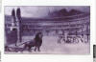 EVENT E: The Persecution of Christians - An engraving of Christian martyrs in the Circus Maximus in Rome, awaiting a gruesome death. The stands are filled with Romans who have come to watch them be eaten by wild animals or burned alive on crosses. In the foreground, a lion stalks out of an underground passageway, followed by a tiger and another lion. In the background, Christians are tied to crosses, and several of them are shrouded in flames and smoke.
Peter was a disciple and a close friend of Jesus. For unknown reasons - though probably for his own position as a leader of the early Christian community in the Roman Empire - he was martyred around the same time as was Paul. In this passage Peter encourages Christians to maintain their faith, even in the face of persecution. When Peter writes about Christians being "zealous for what is right," he refers to them openly witnessing to their faith in Jesus Christ as their saviour. Peter adds that even if they do suffer, faithful Christians will "be blessed," or be rewarded by God. Finally, Peter advises Christians to not be afraid of their persecutors, but rather to "reverence Christ," or worship God.
Information about Event E
As the number of Christians grew, they attracted the attention of Rome. In part, this was because their religion compelled them to be devoted to one God and live a new, radical lifestyle compared to how the Romans conducted themselves on a daily basis. Most notably, Christians refused to acknowledge the divinity of the Roman emperor or any of the many Roman Gods. When accused of this heresy, a Christian could gain his or her freedom by lighting incense on an altar dedicated to a Roman God or by simply saying a prayer to the emperor's divine nature. Roman officials generally did not care if Christians believed in the Roman Gods, but they demanded the obedience of all people living in the empire. Christians, however, refused making even insincere gestures toward the Roman Gods, so intense was their commitment to Jesus. Eventually, the religion was declared illegal.
The penalty for refusing to publically worship Roman Gods was death. As a result, Christians were burned to death, crucified, and devoured by wild animals - often in front of large, cheering crowds. The Christians called those who were murdered for their faith martyrs, and their executions caused much amazement at the time. Many stories tell of Christians bravely, if not happily, going to their deaths, even singing hymns to Jesus, as lions or bears tore at their bodies. Though Roman officials thought persecuting Christians would discourage people from adopting or practicing the new religion, their actions had the opposite effect. Christianity spread because more people wanted to learn about Jesus after witnessing the intense faith of the Christians.
Romans also persecuted Christians because they did not follow a number of Roman laws or customs. For example, because Jesus had preached peace and love toward all people, the early Christians were pacifists and would not serve in the army. Later, when non-Christian soldiers and high-ranking officers became Christians, Roman officials feared the conversions would undermine the emperor's authority and jeopardize the empire's stability. Christians were also considered strange or subversive because they refused to eat meat prepared by non-Christians; they resisted luxury and personal adornment; they held monogamous marriages to be sacred. By not adopting the accepted Roman lifestyle, Christians became a source of fear and resentment among many non-Christian Romans.
Certain emperors were especially harsh in their persecution of Christians. roman officials even blamed and punished Christians for plagues, famines, and other disasters. For example, after a huge fire destroyed much of Roma in 64 C.E., the emperor, Nero, blamed the Christians and had hundreds and possibly thousands of them brutally killed. For the next 25 years, Christians kept a low profile, successfully avoiding persecution. But for 250 years thereafter, Roman emperors continued to persecute them. While some leaders, such as Trajan, did not actively hunt down Christians, other emperors, such as Dacius, Valerian, and Docletian, intensified the persecution.
Conclusion:
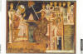 The Donation of Constantine
Despite waves of brutal persecution, Christianity continued to spread throughout the Roman Empire. According to recent estimates, there were at least five million Christian followers by the year 300 C.E. In its earliest years, Christianity was adopted by members of the lower economic classes. They were attracted to a religion that provided a community for them and the promise of salvation in the afterlife. With time, people from all classes, from all over the empire, converted to Christianity. Many were tired of continual warfare and sought the peace and security Christianity promised.
After centuries of persecution and rejection, Christians began to gain some acceptance. Under the emperor Constantine I (280 - 337 C.E.), the conflict between Roman authorities and the Christian church finally began to diminish. After a powerful religious experience, Constantine converted to Christianity in 312 C.E. According to a legendary event known as the Donation of Constantine, the emperor bestowed the primacy of the church and the rule over the west on Pope Sylvester in the early fourth century C.E. In 313 C.E., he issued the Edict of Milan, restoring freedom to Christians to practice their religion openly, and making Christianity equal to all other religions in the Roman Empire. Eventually, in 395 C.E., Christianity became the official state religion of the Roman Empire.

